**Exercise 4: Create a Trigger to Validate the Names of New Products**

Develop a trigger that validates a ProductName in the Products table before insertion. The name of a product must start with an uppercase letter and be at least five characters long.

Test: Try to insert a few test records into the Products table to ensure the trigger validates the names of products correctly.

Explanation:

The trigger function validate_product_name ensures that the ProductName starts with an uppercase letter and is at least 5 characters long. If the condition isn't met, it raises an exception.

Test the trigger by trying to insert both valid and invalid product names. The invalid one should fail, displaying the custom error message.

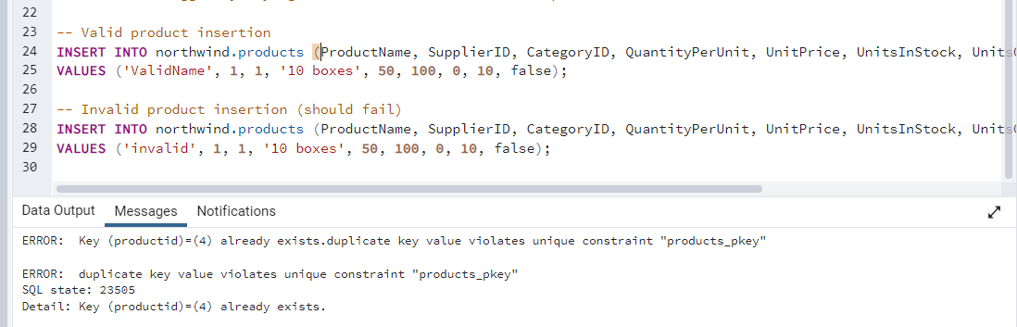

There is error with duplicate key value that’s why I used manually insert ID.

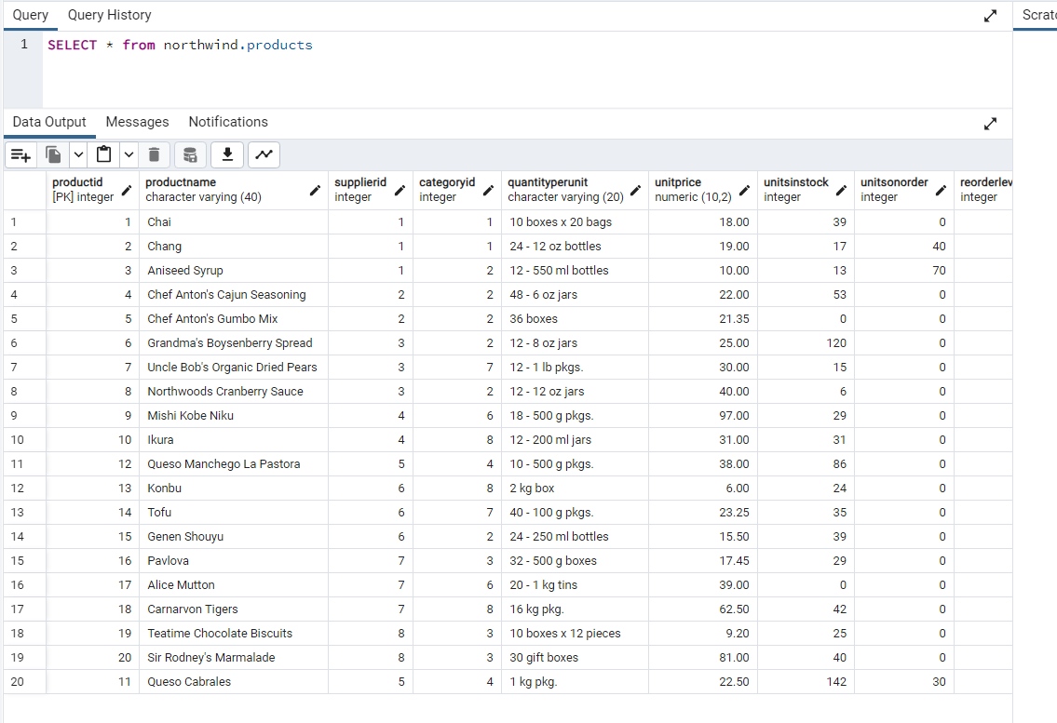

As this DB we need to insert with 21 ID

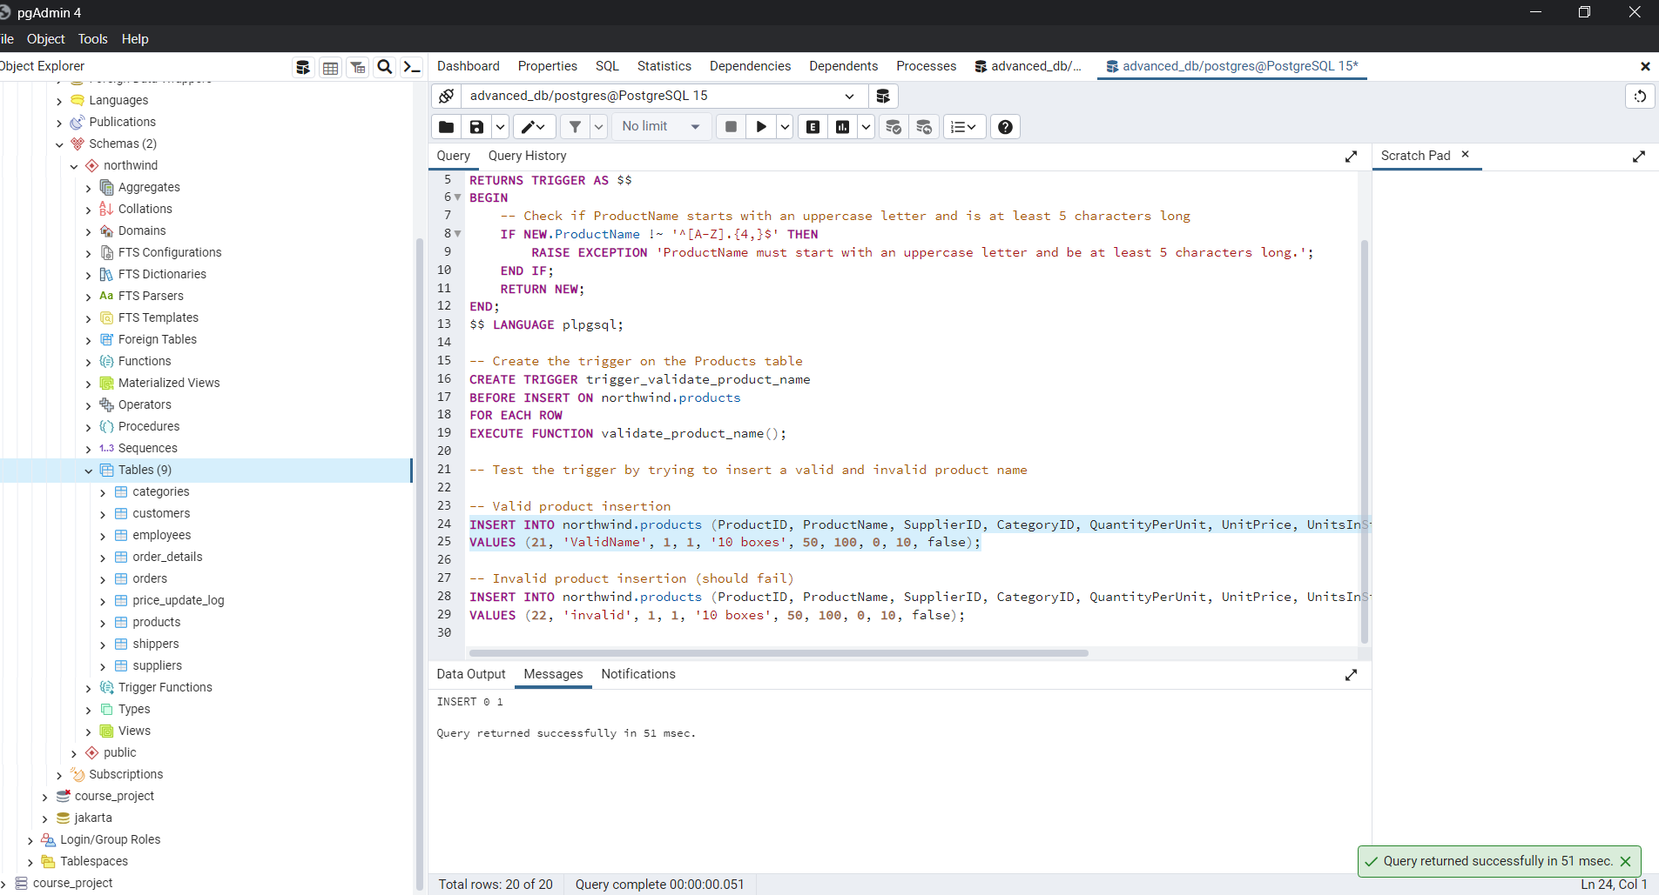

And it successfully inserts as it is valid product because inserting with first capital letter  
  
and trying with invalid data:

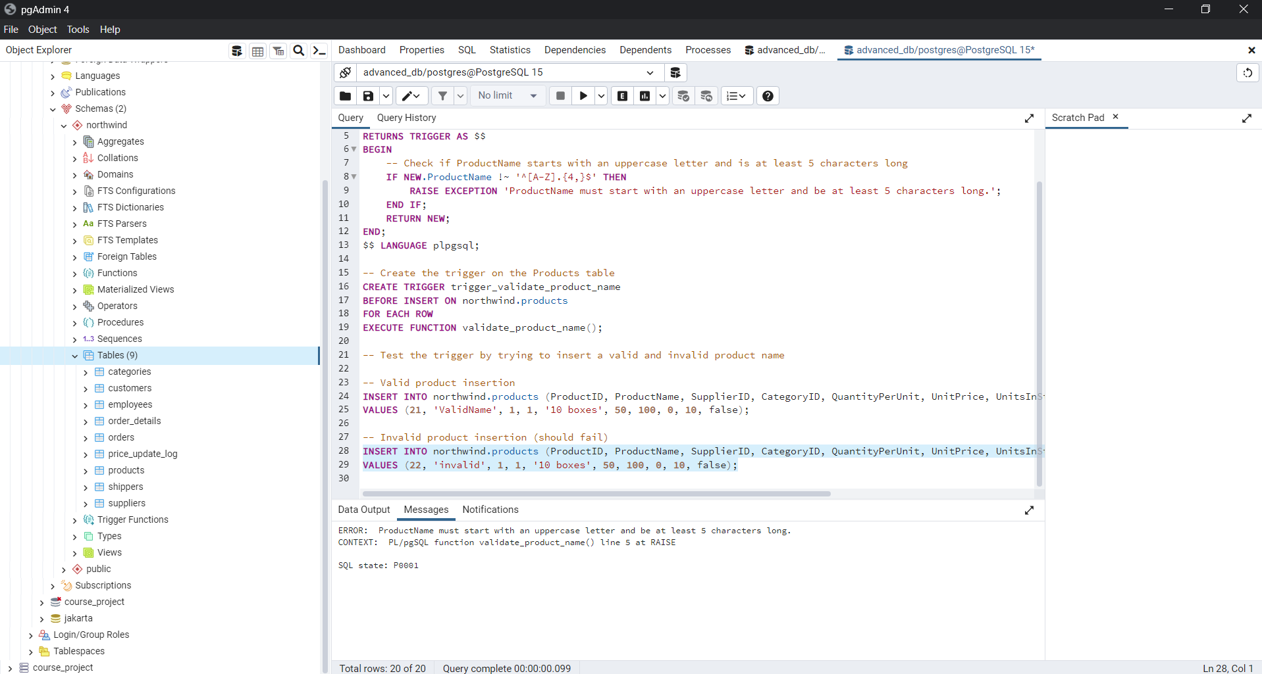

It says:

ERROR: ProductName must start with an uppercase letter and be at least 5 characters long. CONTEXT: PL/pgSQL function validate_product_name() line 5 at RAISE SQL state: P0001  
  
Because how task’s requirement was…

And Final result:

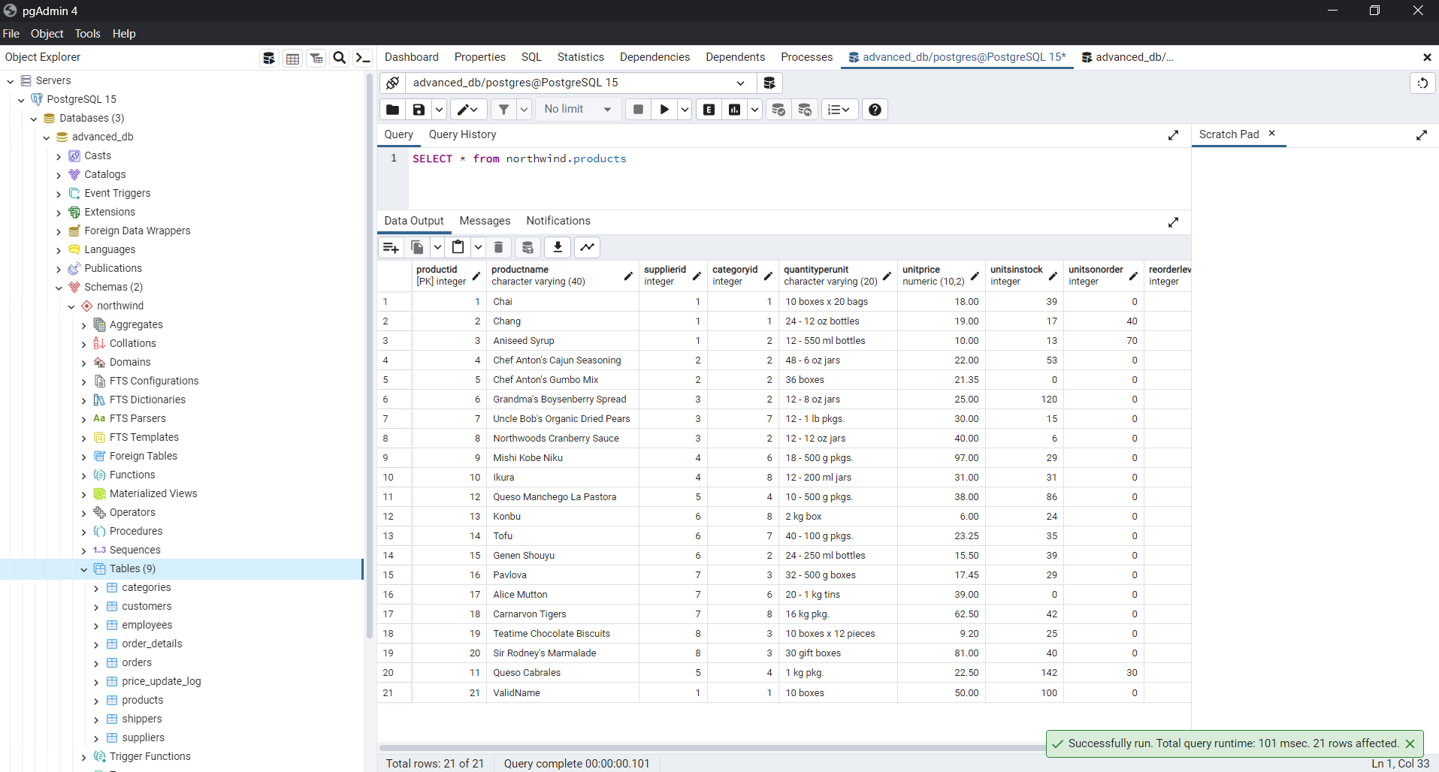

There is ValidName and there is no invalid name.